
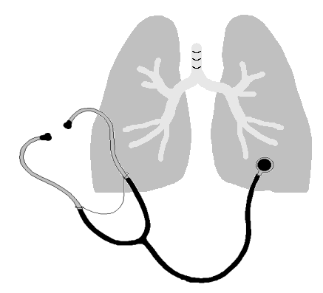
David Panossian, M.D.
2614 Almond Street, Klamath Falls, Oregon 97601
(541) 885-2201, FAX (541) 883-1400

Klamath Pulmonary & Critical Care Medicine
Klamath Sleep Medicine Center

Name: ________________________________________
Height: ______________
Weight: ______________
Age: ________________

STOP-BANG Sleep Apnea Questionnaire

STOP | YES | NO
Do you SNORE loudly (louder than talking or loud enough to be heard through closed doors)?
Do you often feel TIRED, fatigued, or sleepy during the daytime?
Has anyone OBSERVED you stop breathing during your sleep?
Do you have or are you being treated for high blood PRESSURE?

BANG | YES | NO
BMI: more than 35 kg/m2?

AGE: over 50 years old?

NECK: circumference>16 in (40 cm)

GENDER: MALE

Total Score

Yes
High risk of OSA: 5-8
Intermediate risk of OSA: 3-4
Low risk of OSA: 0.2

